DISTRICT INSTITUTE OF EDUCATION AND TRAINING,
Uthamacholapuram, Salem
Reflections of the Discussion made with Azim Premji University, Bangalore
The Co-ordination meeting with Senior faculty, Mr. Ramnath of Azim Premji Foundation and District Educational Officer ( Elementary) was held on 09.11.22 at Conference Hall, DIET, Uthamacholapuram, Salem. The session started formally with the invocation to Tamil Goddess, followed by a Welcome address delivered by Dr. B. Ananthi, Lecturer. Newsletters and Program Documents were released along with the Principal address by Dr.M. Selvam, Principal of the DIET, on the special occasion.
Dr. Nagalakshmi, Senior Lecturer gave a brief introduction about the DIET faculty members. Senior faculty of every Branch of the DIET gave an elaborate explanation of the regular as well as special work carried out by them through Power Point Presentations.
Mr. Santosh, District Educational Officer ( Elementary) marked his observations upon the impact of DIET's activities in the field.
Mr. Ramnath, Senior Faculty of Azim Premji Foundation, keenly observed the activities elaborated by the faculty members and interacted with them to get a deeper insight. He further gave his reflections and inputs for the betterment of DIET.
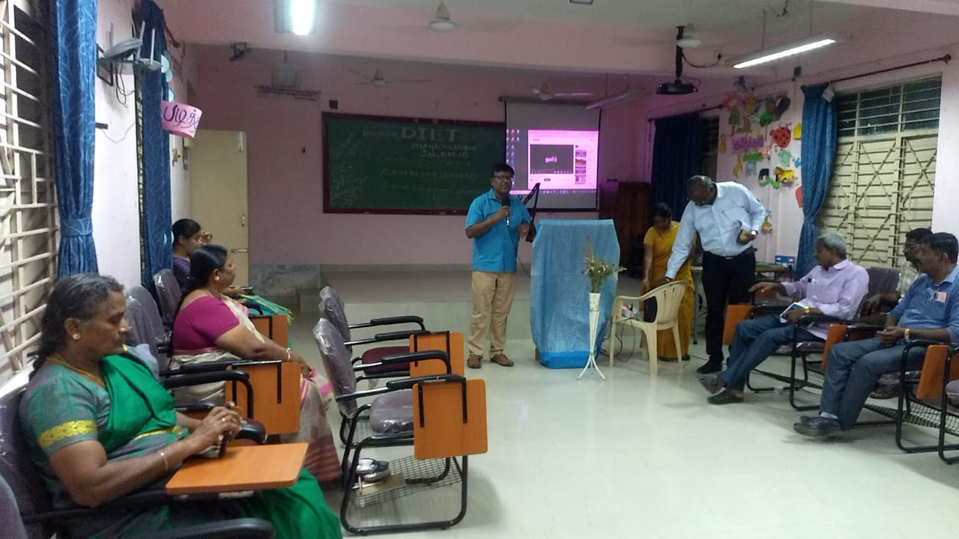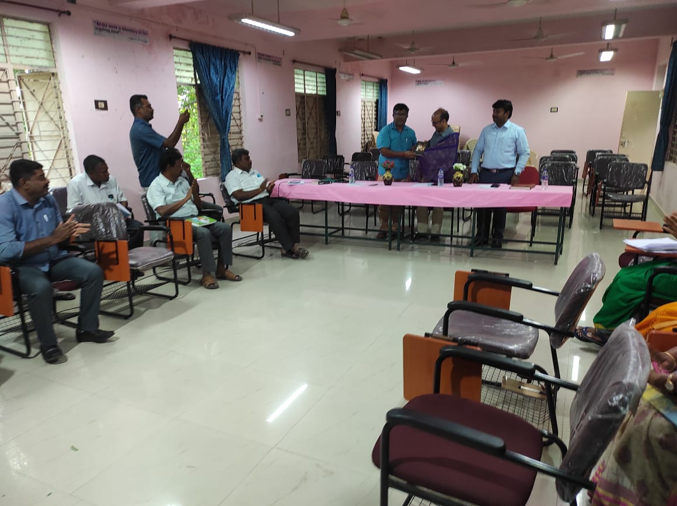
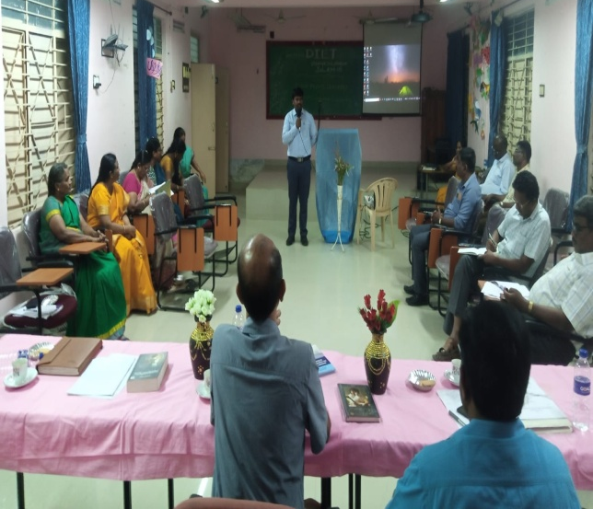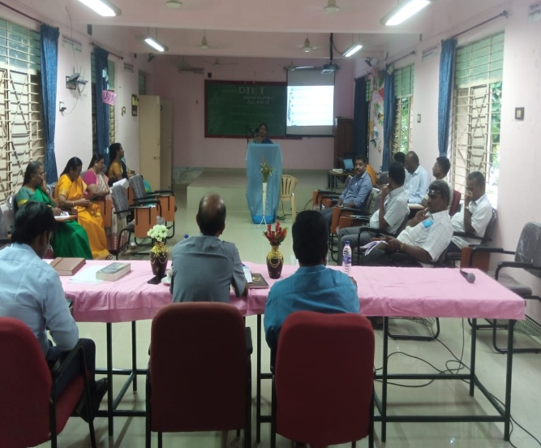
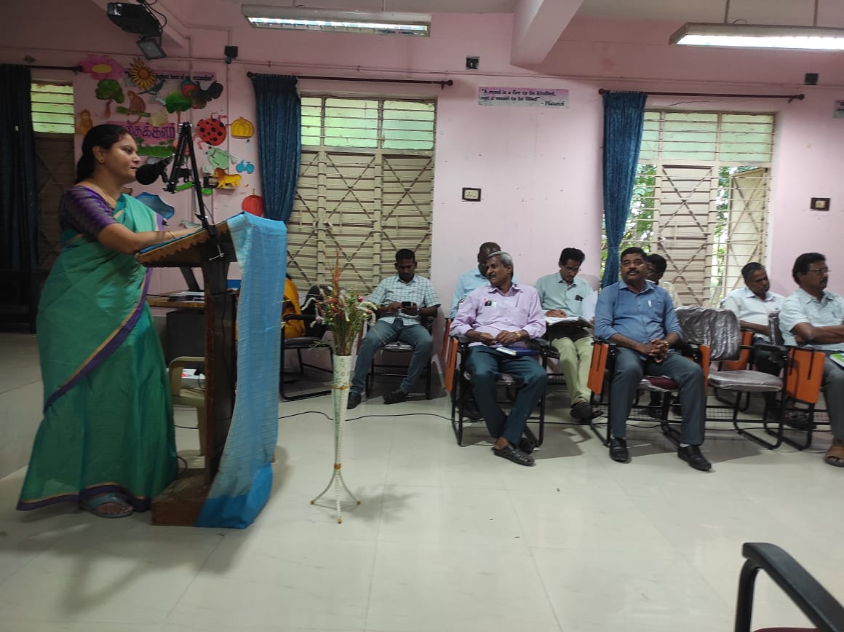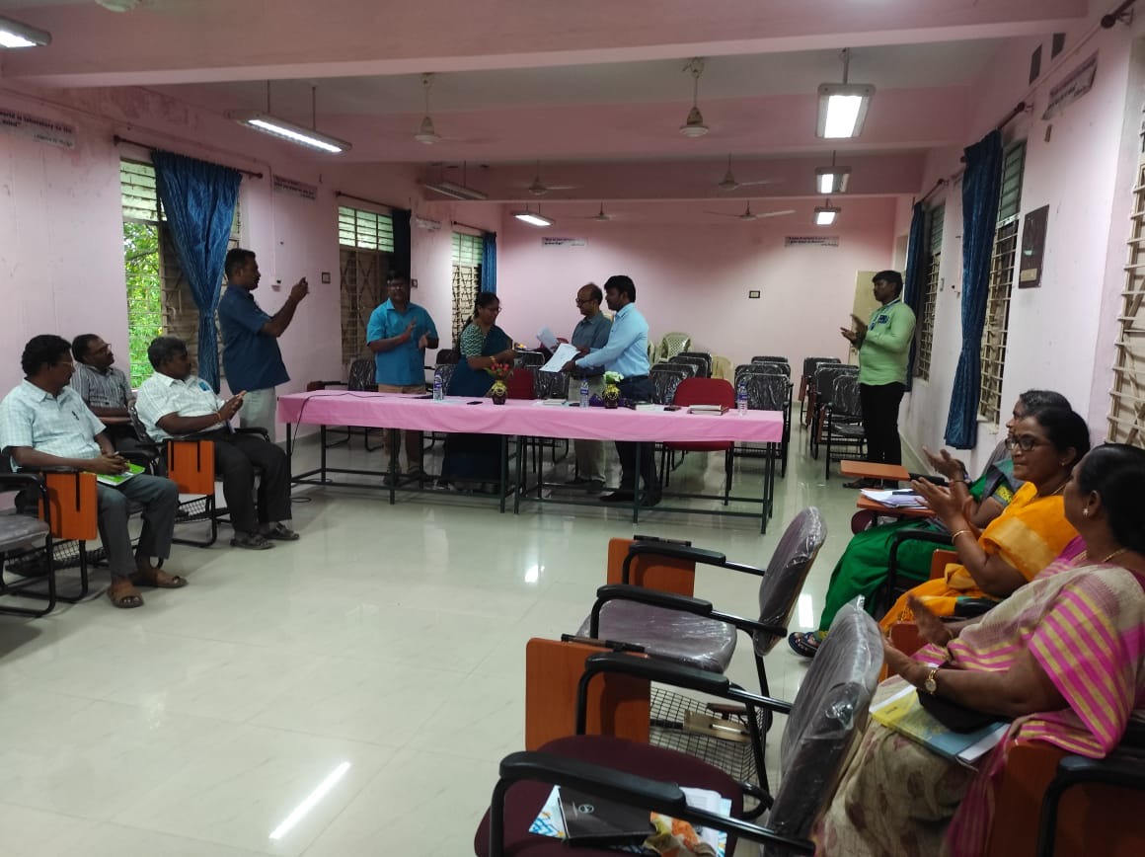
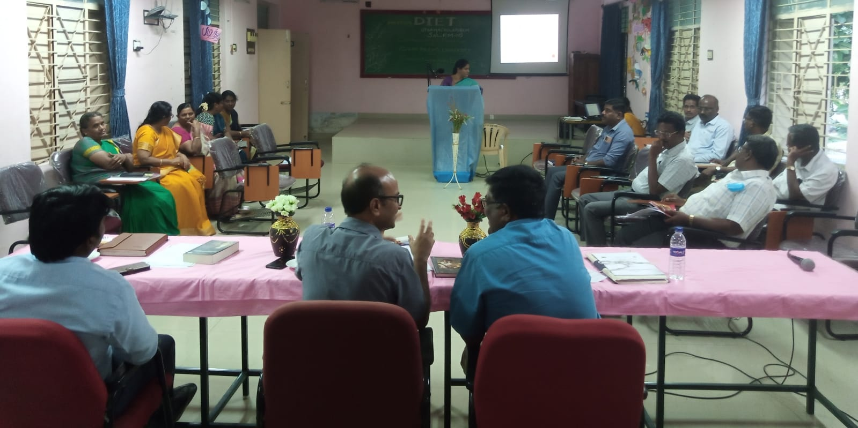

Suggestions given:
1. Linkage of real-life situations/ examples to achieve Learning Outcomes.
2. Integration of subject-wise Content based on selective themes / topics (Spiral Curriculum)
3. Addressing the challenges in teaching and handling of the textbooks.
4. Concept of 'Essential Training' could be incorporated in DIET's Newsletter.
5. A standard PPT Template to be used for all DIET Programs and activities.
6. Availability of findings of Action Researches and Research Projects and also maximising them to the reach of teachers.
7. Building strong linkage of DIET with CEO, DEOS and Schools.
The Library resources and the DIET premises were observed by Mr.Ramnath and Mr. Santosh, DEO. Suggestions to make maximum utility of Library books among teachers and school students were shared with the Principal and Librarian.
On the lines of suggestions and inputs, Vote of thanks was rendered by Dr. R. Nagalaksmi, Senior Lecturer. All the faculty members were greatly inspired and motivated by the end of the day through this co-ordination meeting.

Suggestions incorporated by DIET, Salem:
1. As a reflection of the suggestion given to build a strong linkage of DIET with CEO, DEOS and Schools, a District level 'Learning Outcomes' Training was disseminated by DIET, Salem to 740 Head Masters of Middle, High and Higher Secondary Schools in collaboration and co-operation with the CEO of Salem, at Padmavani Arts and Science College from 14.11.22 to 19.11.22
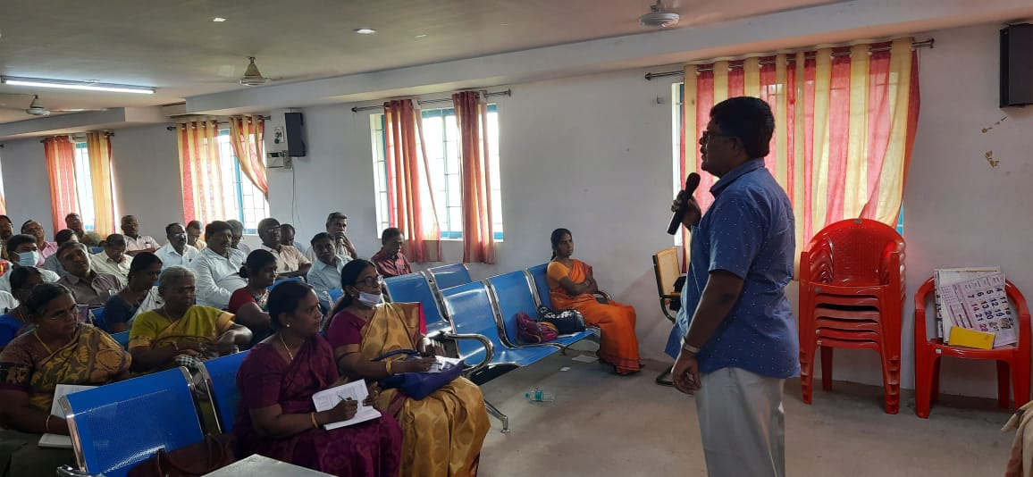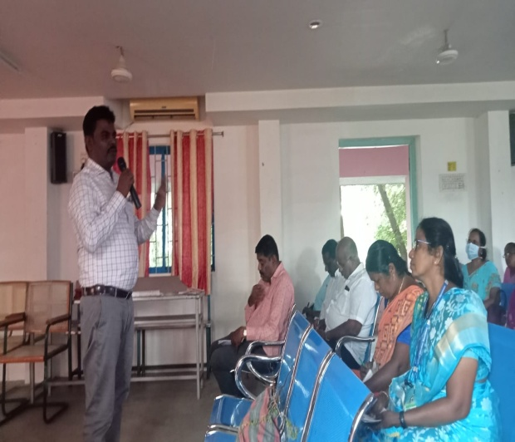

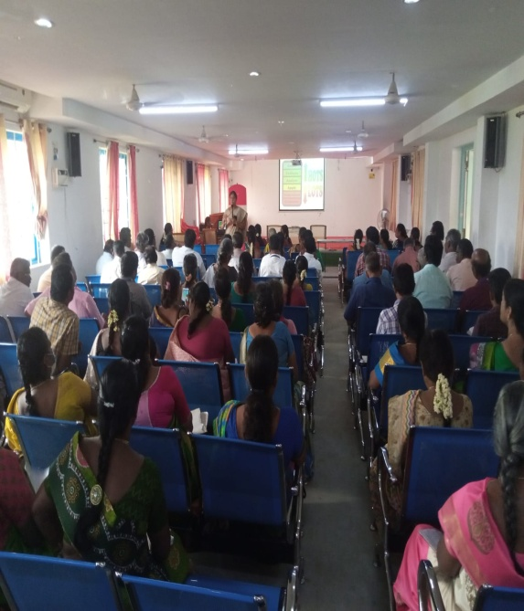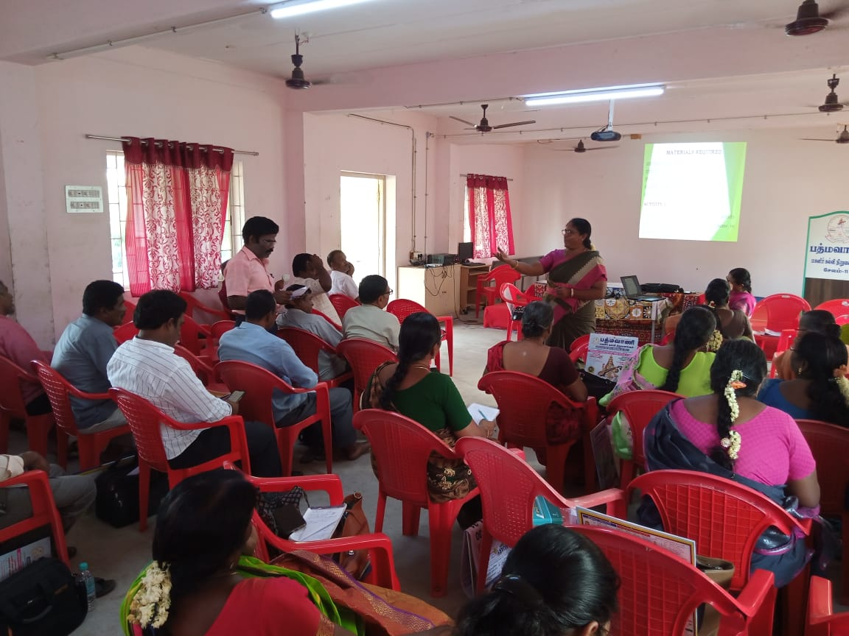

2. A standard PPT Template was designed used by the DIET faculty for the recent Head Masters' Training at Padmavani Arts and Science College. It is also decided that the same will be used henceforth.
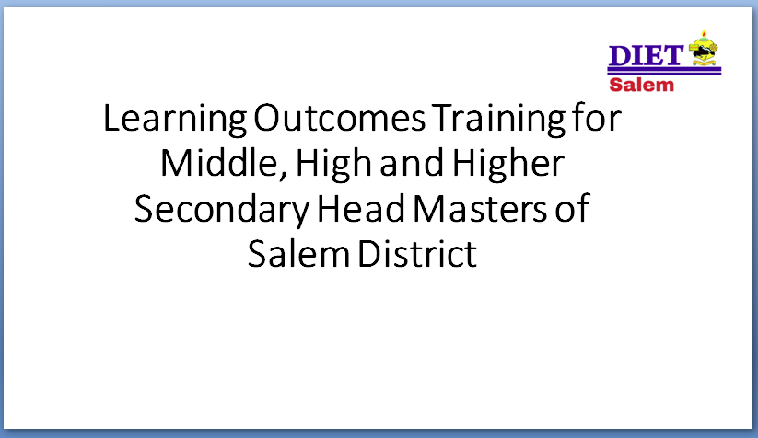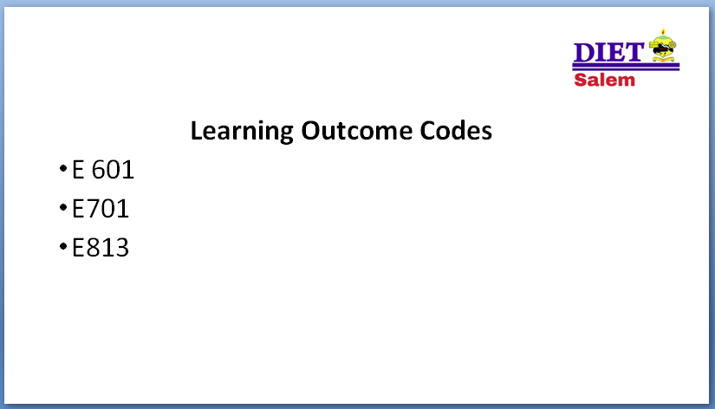
3. A planning meeting was convened by Dr. M. Selvam, Principal, DIET, Salem on 21.11.22 to implement two other suggestions of Mr. Ramnath, Senior faculty of Azim Premji Foundation. One is to link real-life situations/ examples with Learning Outcomes and the other is to integrate subject-wise Content based on selective themes / topics, facilitating a Spiral Curriculum.
It was planned that the faculty members will take up a topic each from Grade 6 and design a sample to link real-life situations with Learning Outcomes. They also will take up a common topic / theme and plan examples based on concerned subjects. A brainstorming session is planned to be conducted on 23.11.22 in this regard, after which similar plans will be done for all grades and more themes/ topics in the near future.
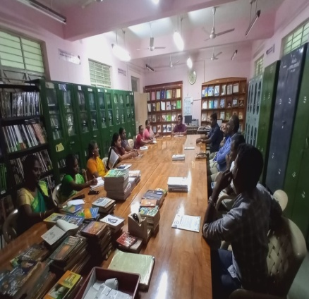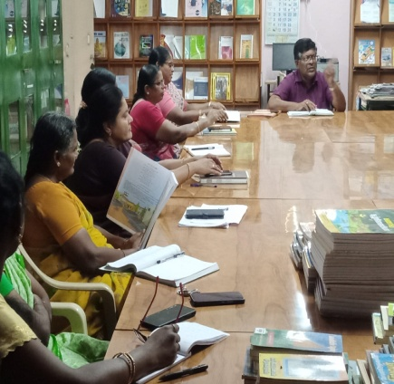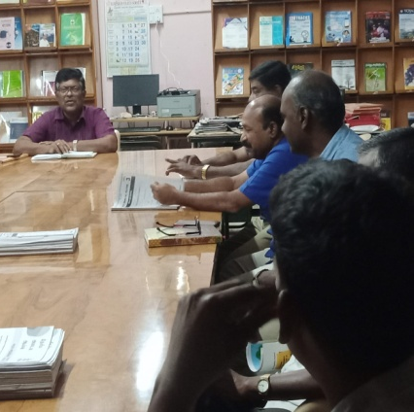
Other suggestions given by Mr. Ramnath, Senior faculty of Azim Premji Foundation will also be incorporated by DIET, Salem in due course of time.

